

**CIA4U**

**Lesson 1.1 Asking Economic Questions Assignment**

**Type of Assessment: Homework**

**Purpose of Assessment: Assessment FOR Learning**

**Method of Assessment: Yes/No**

**Learnings Goals:**

* formulate different types of questions to guide investigations into current national and global economic issues
* select and organize relevant data, evidence, and information on current Canadian and international economic issues from a variety of primary and secondary sources
* assess the credibility of sources, data, evidence, and information relevant to their investigations
* interpret and analyse data, evidence, and information relevant to their investigations, using various tools, strategies, and approaches appropriate for economic inquiry
* use the concepts of economic thinking
* communicate their ideas, arguments, and conclusions using various formats and styles, as appropriate for the audience and purpose

|  |  |
| --- | --- |
| **Economic Inquiry and Skill Development** | Economic Inquiry: use the economic inquiry process and the concepts of economic thinking when investigating current Canadian and international economic issues; |

|  |  |
| --- | --- |
| Ontario Curriculum Expectations | |
| **A1.1** | formulate different types of questions to guide investigations into current national and global economic issues |
| **A1.2** | select and organize relevant data, evidence, and information on current Canadian and international economic issues from a variety of primary and secondary sources |
| **A1.3** | assess the credibility of sources, data, evidence, and information relevant to their investigations |
| **A1.5** | use the concepts of economic thinking |
| **A1.7** | communicate their ideas, arguments, and conclusions using various formats and styles, as appropriate for the audience and purpose |

**Instructions:**

Read this article:

# *[Toronto protest against Dakota Access pipeline snarls downtown traffic](https://www.thestar.com/news/gta/2016/09/13/anti-pipeline-protesters-block-traffic-on-king-st.html)*

## *More than 100 participants are blocking streets to protest the pipeline project.*

*By Alicja SiekierskaStaff Reporter*

*​​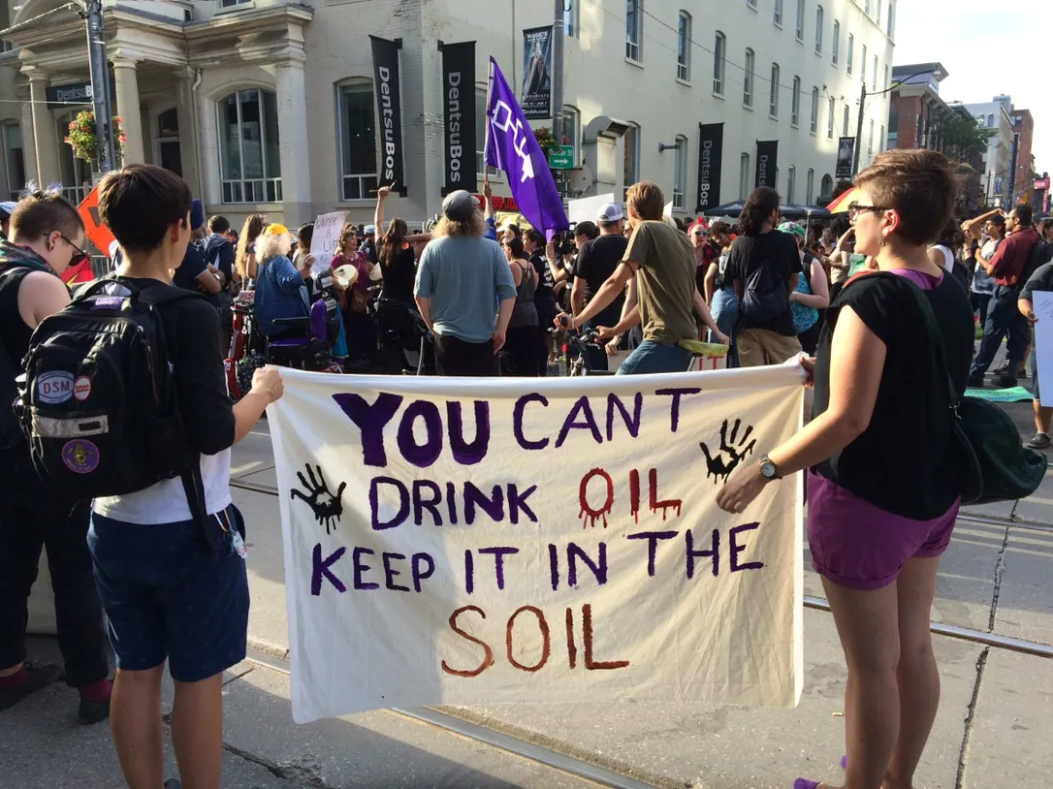*

*Traffic came to a standstill in parts of downtown Toronto on Tuesday evening as about 150 people protested the Dakota Access pipeline being built in the United States.*

*The protest began at 3:30 p.m. at the stock exchange on King St. before weaving its way through downtown. Demonstrators made a brief stop beside a Toronto International Film Festival venue and continued peacefully to Yonge-Dundas Square.*

*Although the protest stopped near the TIFF area, Carrie Lester, a protester from Mohawk Six Nations Grand River, said that was not the purpose of the march. Shortly after the brief pause, the group began walking north towards Queen St., with some protesters pushing anti-pipeline signs against the window of a limo driving towards the film festival.*

*People waved signs, chanting “Keep it in the soil, you can't drink oil” as they marched in solidarity with the people of Standing Rock Sioux Tribe, which has been conducting a blockade of pipeline construction for weeks.*

*The group stopped at intervals, holding up traffic while joining hands to form a giant circle surrounding indigenous drummers and singers.*

*As she walked down Yonge St., Lester said it's crucial for people all over the world to speak up against oil pipelines that she said are destroying the environment.*

*“It's up to me, it's up to all of us, to protect our land and water,” Lester said. “We can't let these extractive industries continue what they're doing. They've held a noose around our neck for far too long.”*

*Lester said this was the third such demonstration in Toronto in recent weeks.*

*The Standing Rock Sioux Tribe in North Dakota is suing federal regulators for approving the oil pipeline, arguing it will harm water supplies and disturb sacred burial and cultural sites.*

*Dorian Douma, who learned about the march on Facebook, hopes the Toronto protest raises awareness about the battle Standing Rock Sioux Tribe is undertaking.*

*“It's important to show our solidarity with them and it's important for Torontonians to learn about what is happening,” he said.*

*Protests continued in North Dakota on Tuesday, with 22 people arrested for interfering with pipeline construction. A sheriff’s office spokeswoman told the Associated Press that construction workers were “swarmed” by protesters and that two people had “attached” themselves to equipment.*

*Amy Goodman, an award-winning broadcast journalist for Democracy Now! spoke in Toronto on Saturday at a TIFF panel on the film All Governments Lie, two days after Morton County, N.D., issued an arrest warrant charging her with criminal trespass after she filmed the protest.*

*“Somebody has to be doing this,” said Allan Henderson, of Mitaanjigamiing First Nation, who led the singing throughout the march. “We do it for our grandkids. We do it for our great-grandkids. There are women here who are pregnant, and they would love to see clean water for their kids.”*

*With files from the Associated Press*

Using the article and accompanying photo in the Action section, write 1-2 sentences for each using the following prompts:

* + **CONNECT:** How are the ideas and information presented CONNECTED to what you already knew?

|  |
| --- |
|  |

* + **EXTEND:** What new ideas did you get that EXTENDED or pushed your thinking in new directions?

|  |
| --- |
|  |

* + **CHALLENGE:** What is still CHALLENGING or confusing for you to get your mind around? What questions, wonders, or puzzles do you now have?

|  |
| --- |
|  |

**Submit your assignment in your shared course folder.**